TITLE (14pt, bold, center, CAPITAL LETTERS)
Empty row
First name Family name¹, First name Family name², First name Family name³ (12pt, italic)
¹Institution, address (10pt)
²Institution, address (10pt)
E-mail:
ABSTRACT (12pt, bold, 12pt space before paragraph)
Article should be written in format A4, with all margins set to 2.5 cm, (frame size 16×24.7 cm) just like in this template. Indent of the first sentence of text body should be set to 1 cm, justify, single space, font Times New Roman CE 12 pt. E-mail of corresponding author should be submitted below Institution address.
Key words: up to five keywords.
INTRODUCTION (12pt, bold, 12pt space before paragraph)
Article should be written in format A4, with all margins set to 2.5 cm, (frame size 16×24.7 cm) just like in this template. Indent of the first sentence of text body should be set to 1 cm, justify, single space, font Times New Roman CE 12 pt. Titles within text body are not obligatory.
The total size of the manuscript should not exceed 4 pages (camera ready) for section lectures and 1-2 pages for plenary lectures. Manuscript must be written in English.
EXPERIMENTAL (if any, 12pt, bold, 12pt space before paragraph)
Manuscript (preferably in word) should be be submitted online through the paper submission form: http://si-za.si/10-ssh-symposium-on-zeolites/paper-submission/ before February 15, 2024.
RESULTS AND DISCUSSION (12pt, bold, 12pt space before paragraph)
Figs, Tables and Equations should be included in text body. Equations should be mark by numbers in parenthesis leaving at least 1 cm free space at both sides (left-right) and 6 pt of free single space before and after equation.
xx = eq^{ua}t_{io}n more & more something (1)
Figs and Tables descriptions must be in english. Examples below does not reflect real size nor the number of columns or raws. in References should be formated as it is shown below, in this example.
Empty row before and after tables and figs
Table 4. Distribution of different silicate species in the Me-silicate solutions S1 – S5.
Solution | 1 | 2 | 3 | 4 | 5
 | yo | man | wh | at‘s | up
Monomer | 43.5 | 41.2 | 36.2 | 32.0 | 31.7
Dimer | 35.6 | 15.0 | 15.7 | 12.8 | 15.6
linear trimer + linear tetramer + branched cyclic trimer | - | 16.4 | 9.5 | 11.6 | 10.3
cyclic trimer | 12.0 | 9.3 | 9.6 | 8.8 | 9.3
cyclic tetramer | - | 11.3 | 11.0 | 12.6 | 14.0
branched cyclic tetramer | 8.9 | - | 5.7 | 8.1 | 6.6
bicyclic pentamer | - | 4.6 | 5.4 | 5.7 | 4.4
prismatic hexamer | - | 2.2 | 6.6 | 8.7 | 8.1
Empty row before and after tables and figs
Fig. example below does not reflect real size and the number of columns or rows. References should be format as it is shown below.
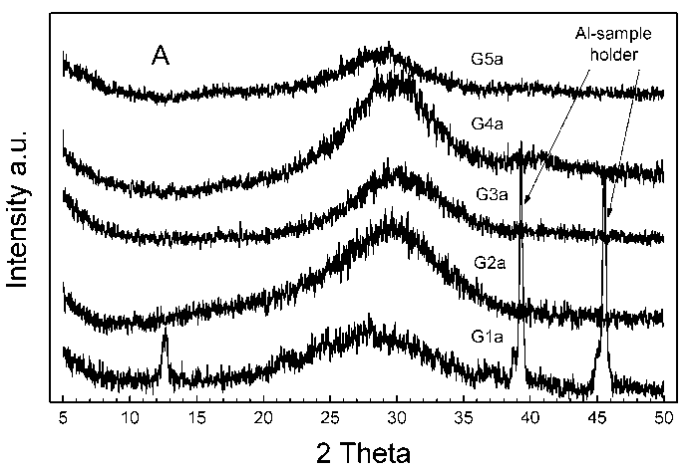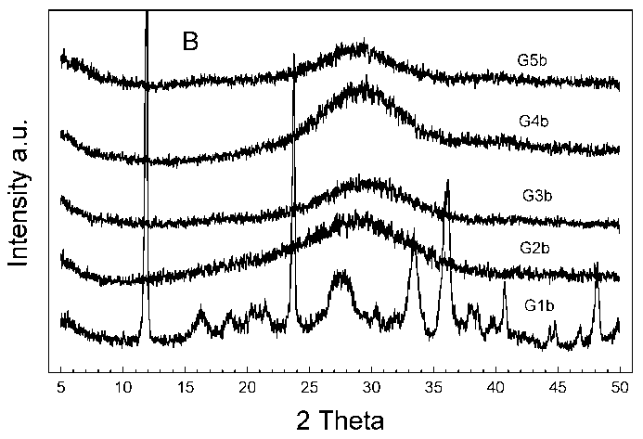
Figure 1. X-ray diffraction patterns of gels (A): this is just demonstration of possibility to put 2 figs next to each other and that the font size is 10 pt.
CONCLUSION (12pt, bold, 12pt space before paragraph)
Articles should be written on format A4, with all margins set to 2.5 cm, (frame size 16×24.7 cm) just like in this template. Indent of the first sentence of text body should be set to 1 cm, justify, single space, font Times New Roman CE 12 pt. Titles within text body are not obligatory.
REFERENCES (12pt, bold, 12pt space before paragraph)
[1] H. Thomas, A. Novak and T. Rock, Title, Journal or Book Title, Year, Volume, Pages.

